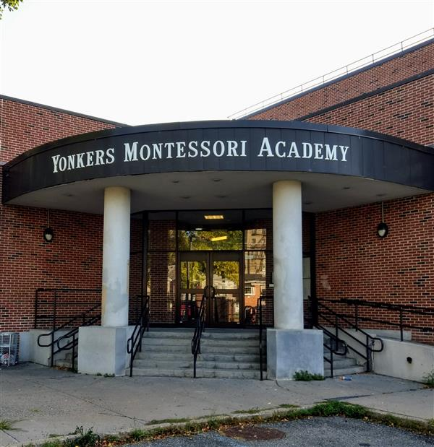

MINIMUM CAPACITY :-

The Minumum intake capacity

of students is between 300-620

children

LIBRARY :-

The Libarary is Available.

CANTEEN:-

The Canteen Facility is Available.

BOARDING :-

No availablility of boarding.

SPORTS :-

There are different categories

sports available.

Girls Volleyball

Boys Volleyball

Football

|  |  |  |
| --- | --- | --- |
| YONKERS MONTESSORI ACADEMY  YONKERS - SCHOOL |  |  |
|  |  |  |
| School Detail :- The students, parents, staff and community of the Patricia A. DiChiaro School are committed to academic excellence in a positive learning environment. All students will achieve high standards in this safe and creative atmosphere. At the Patricia A. DiChiaro School collaboration and cooperation successfully prepare our students for the future  . |  |